**Twitter Sentiment Analysis**

**COURSE PROJECT REPORT**

**18CSE398J -Machine Learning - Core Concepts with Applications**

**(2018 Regulation)**

**III Year/ VI Semester**

**Academic Year: 2022 -2023 (EVEN)**

By

**NAMAN ANAND – RA2011029010013**

**SRINIVAS T.B. – RA2011029010015**

**KIRTI KALAL – RA2011029010031**

Under the guidance of

**DR.G. VADIVU**

**Professor**

**Department of Data Science and Business Systems**



**DEPARTMENT OF DATA SCIENCE AND BUSINESS SYSTEMS**

**FACULTY OF ENGINEERING AND TECHNOLOGY**

**SRM INSTITUTE OF SCIENCE AND TECHNOLOGY**

**Kattankulathur, Kancheepuram**

**MAY 2023**

**TABLE OF CONTENTS**

|  |  |
| --- | --- |
| **1. Abstract** | 1 |
| **2. Introduction** | 2 |
| **3. Dataset** | 3 |
| **4. Methods** | 4 |
| 4.1 NLTK(Natural Language Toolkit)………………………… | 4 |
| 4.2 Scikit-learn………………………………………………… | 5 |
| 4.3 Gensim ……………………………………………………. | 5 |
| 4.4 Matplotlib | 6 |
| 4.4 Seaborn……………………………………………………. | 6 |
| **5. Experiments And Results** | 7 |
| 5.1 Distribution of Data………………………………………... | 9 |
| 5.2 Preprocessing of Text……………………………………. | 10 |
| 5.3 Generating Word Cloud…………………………………. | 11 |
| 5.4 Finding Similar Words…………………………………….. | 13 |
| 5.5 Result……………………………………………………… | 13 |
| 5.6 Github Links………………………………………………. | 14 |
| **6. Conclusion And Future Works** | 15 |
| 6.1 Future Works………………………………………………. | 16 |
| **References** | 18 |

**ABSTRACT**

Twitter Sentiment Analysis is the process of extracting and categorizing emotions expressed in tweets posted on the social media platform Twitter. This technique has become increasingly popular in recent years due to the growing availability of large amounts of social media data, which can be used to gain insights into public opinions and attitudes towards various topics, products, or events.

Machine learning algorithms have proven to be effective in analyzing large datasets and classifying the sentiment of tweets as positive, negative, or neutral. This project aims to explore the use of machine learning algorithms to analyze Twitter sentiment and determine the effectiveness of different techniques for this task.

The project will involve collecting and preprocessing a large dataset of tweets, selecting appropriate features for sentiment analysis, and training and testing various machine learning models to predict the sentiment of tweets, and the project also involves generating word clouds, finding similar words.

The results of this project can have practical applications in various fields, such as marketing, politics, and social research, by providing insights into public opinion and sentiment towards products, services, events, or political issues.

**INTRODUCTION**

Sentiment analysis (also known as opinion mining or emotion AI) is the use of natural language processing, text analysis, computational linguistics, and systematically identify, extract, quantify, and study affective states and subjective information. It identifies the emotional tone behind a body of text. Sentiment analysis is widely applied to voice of the customer materials such as reviews and survey responses, online and social media, and healthcare materials for applications that range from marketing to customer service to clinical medicine.

A sentiment analysis tool is an automated technique that extracts meaningful information related to a person’s attitudes, emotions, and opinions.

A basic task in sentiment analysis is classifying the polarity of a given text at the document, sentence, or feature/aspect level—whether the expressed opinion in a document, a sentence or an entity feature/aspect is positive, negative, or neutral.

A Twitter sentiment analysis is the process of determining the emotional tone behind a series of words, specifically on Twitter.

Twitter sentiment analysis allows to keep track of what's being said about any product or service on social media, and can help detect angry customers or negative mentions before they escalate. Python is widely used for twitter sentiment analysis.

It therefore means, using advanced text mining techniques to analyze the sentiment of the text (here, tweet) in the form of positive, negative and neutral. It is also known as Opinion Mining, is primarily for analyzing conversations, opinions, and sharing of views (all in the form of tweets) for deciding business strategy, political analysis, and also for assessing public actions. Python is widely used for twitter sentiment analysis.

**DATASET**

The Twitter dataset extracted through a script is a collection of tweets that were scraped using a custom Python script. The dataset contains a vast amount of text data, including the tweet's content, author, location, date, and any associated metadata. The tweets in the dataset can be filtered and sorted by keywords, hashtags, or user accounts.

The dataset is ideal for text analysis and machine learning projects, as it contains a variety of tweet types, including retweets, quotes, and replies. The data can be used to analyze trends in social media conversations, sentiment analysis, and topic modeling.

The Twitter dataset extracted through a script is updated frequently and can be easily integrated into existing data science workflows. The dataset's rich metadata provides additional insights into Twitter users' behavior, such as the number of followers, engagement rates, and tweet frequency.

Overall, this Twitter dataset provides a valuable resource for researchers, marketers, and data scientists looking to gain insights into social media conversations and trends.

The dataset contains 1048576 rows of data. The attributes in the dataset are as follows:

* First column shows the emotion of the tweet.
* Second column shows the unique id of the tweet.
* Third column shows the day, date, and time of the tweet.
* Fourth column shows
* Fifth column shows the username of the user.
* Sixth column shows the tweet done by a particular user.

**METHODS**

The libraries used in the project are explained below:

**NLTK (Natural Language Toolkit)**

NLTK is one of the most widely used NLP libraries in Python. It provides a comprehensive suite of libraries and programs for tasks such as tokenization, stemming, lemmatization, and parsing of natural language data. For sentiment analysis, NLTK is often used for text preprocessing, which involves converting raw text data into a format that can be analyzed using machine learning algorithms.

One of the key features of NLTK is its pre-trained classifiers and models. NLTK includes a number of pre-trained classifiers for sentiment analysis, including Naive Bayes, Maximum Entropy, and Support Vector Machines (SVMs). These classifiers can be used to classify tweets into positive, negative, or neutral categories based on their content.

NLTK also includes a number of corpora (collections of texts) that can be used for training and testing sentiment analysis models. For example, the "movie_reviews" corpus contains 2,000 movie reviews that have been classified as either positive or negative. This corpus can be used to train a sentiment analysis model that can then be applied to Twitter data.

**Scikit-learn**

Scikit-learn is a popular machine learning library in Python that provides a wide range of algorithms for classification, regression, and clustering tasks. Scikit-learn includes several machine learning algorithms that are commonly used in sentiment analysis, including Support Vector Machines (SVM), Naive Bayes, and Random Forest.

Scikit-learn can be used for both supervised and unsupervised learning. In supervised learning, the algorithm is trained on a labeled dataset of tweets (i.e., tweets that have been labeled as positive, negative, or neutral), and then used to classify new tweets based on their content. In unsupervised learning, the algorithm is used to identify patterns or clusters in the data without any prior knowledge of the labels.

Scikit-learn also includes several preprocessing and feature extraction modules that can be used to preprocess and analyze textual data. These modules include CountVectorizer, which converts a collection of tweets into a matrix of token counts, and TfidfVectorizer, which converts a collection of tweets into a matrix of TF-IDF features.

One of the advantages of Scikit-learn is its speed and scalability. It can be used to train and evaluate machine learning models on large datasets of tweets in a relatively short amount of time.

**Gensim**

Gensim is a popular library used for topic modeling and text similarity tasks. It includes several modules for analyzing textual data, including pre-processing, similarity measurement, and topic modeling. Gensim can be used to identify the most relevant topics in a tweet dataset, which can help to improve the accuracy of sentiment analysis.

**Matplotlib**

Matplotlib is a popular library used for data visualization tasks. It includes several modules for creating different types of plots and graphs that can be used to visualize sentiment analysis results. Matplotlib can be used to visualize the sentiment distribution of tweets, the most frequent positive and negative words used, and the sentiment of tweets over time.

**Seaborn**

Seaborn is another popular library used for data visualization tasks. It provides several modules for creating statistical visualizations that can be used to analyze and compare sentiment analysis results. Seaborn can be used to create bar plots, heatmaps, and box plots to visualize the sentiment distribution of tweets, the most frequent positive and negative words used, and the sentiment of tweets over time.

**EXPERIMENTS AND RESULTS**

The codes are given below as text and their corresponding output is given as image below the codes.

import re

import numpy as np

import pandas as pd

# plotting

import seaborn as sns

from wordcloud import WordCloud

import matplotlib.pyplot as plt

# nltk

from nltk.stem import WordNetLemmatizer

# sklearn

from sklearn.linear_model import LogisticRegression

from sklearn.model_selection import train_test_split

from sklearn.metrics import confusion_matrix, classification_report

from nltk.corpus import stopwords

import re

import string

import nltk

nltk.download('punkt')

nltk.download('stopwords')

nltk.download('wordnet')

from textblob import TextBlob

from nltk.tokenize import word_tokenize

from nltk.corpus import stopwords

from nltk.stem.wordnet import WordNetLemmatizer

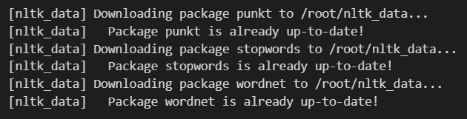

DATASET_COLUMNS=['target','ids','date','flag','user','text']

DATASET_ENCODING = "ISO-8859-1"

data = pd.read_csv('twitter.csv', encoding=DATASET_ENCODING, names=DATASET_COLUMNS)

data.sample(5)

X = data.iloc[:,[5]]

Y = data.iloc[:,0]

Y[Y == 4] = 1

data.head()

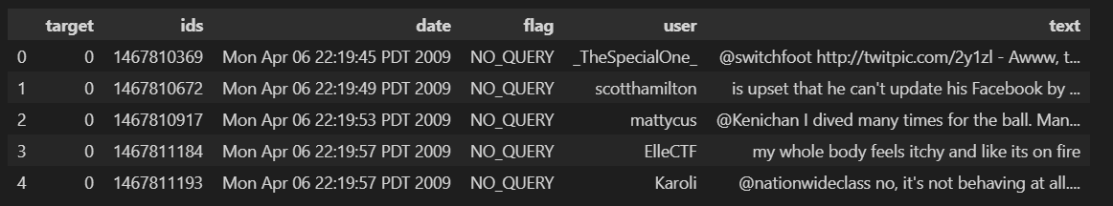

data.columns



print('length of data is', len(data))



data. shape



data.info()

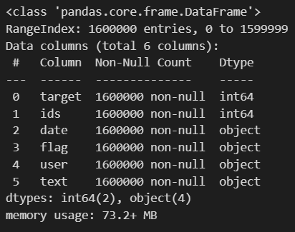

data.dtypes

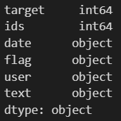

np.sum(data.isnull().any(axis=1))



print('Count of columns in the data is:  ', len(data.columns))

print('Count of rows in the data is:  ', len(data))

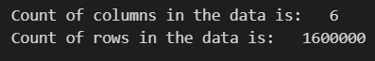

data['target'].unique()



data['target'].nunique()



**Distribution of Data**

ax = data.groupby('target').count().plot(kind='bar', title='Distribution of data',legend=False)

ax.set_xticklabels(['Negative','Positive'], rotation=0)

# Storing data in lists.

text, sentiment = list(data['text']), list(data['target'])

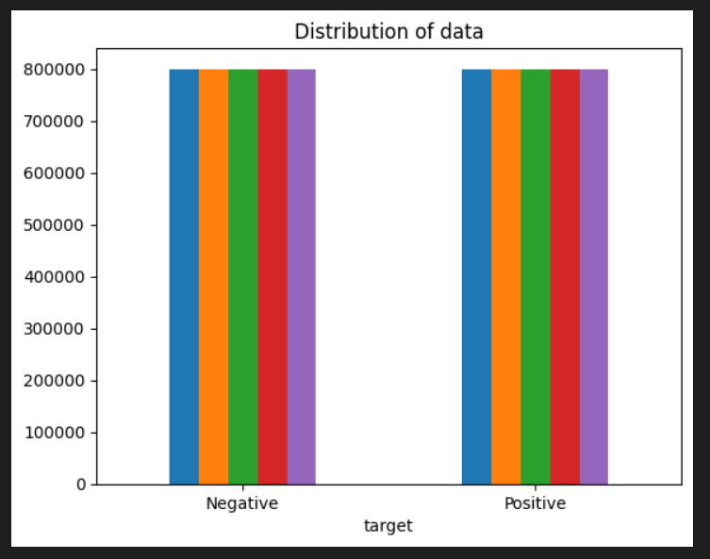

import seaborn as sns

sns.countplot(x='target', data=data)

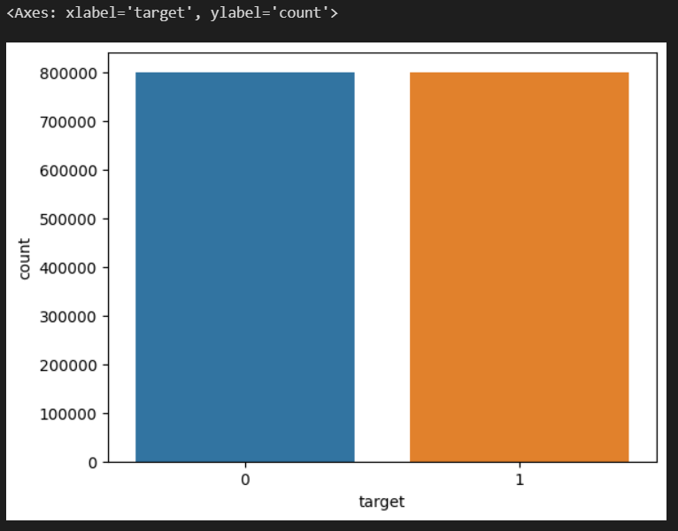

**Preprocessing of Text**

num_missing_desc = data.isnull().sum()[2]    # No. of values with msising descriptions

print('Number of missing values: ' + str(num_missing_desc))

data = data.dropna()

TAG_CLEANING_RE = "@\S+"

# Remove @tags

X['text'] = X['text'].map(lambda x: re.sub(TAG_CLEANING_RE, ' ', x))

# Smart lowercase

X['text'] = X['text'].map(lambda x: x.lower())

# Remove numbers

X['text'] = X['text'].map(lambda x: re.sub(r'\d+', ' ', x))

# Remove links

TEXT_CLEANING_RE = "https?:\S+|http?:\S|[^A-Za-z0-9]+"

X['text'] = X['text'].map(lambda x: re.sub(TEXT_CLEANING_RE, ' ', x))

# Remove Punctuation

X['text']  = X['text'].map(lambda x: x.translate(x.maketrans('', '', string.punctuation)))

# Remove white spaces

X['text'] = X['text'].map(lambda x: x.strip())

# Tokenize into words

X['text'] = X['text'].map(lambda x: word_tokenize(x))

# Remove non alphabetic tokens

X['text'] = X['text'].map(lambda x: [word for word in x if word.isalpha()])

# Filter out stop words

stop_words = set(stopwords.words('english'))

X['text'] = X['text'].map(lambda x: [w for w in x if not w in stop_words])

# Word Lemmatization

lem = WordNetLemmatizer()

X['text'] = X['text'].map(lambda x: [lem.lemmatize(word,"v") for word in x])

# Turn lists back to string

X['text'] = X['text'].map(lambda x: ' '.join(x))



**Generating Word Cloud**

data_neg = X['text'][:800000]

plt.figure(figsize = (20,20))

wc = WordCloud(max_words = 1000 , width = 1600 , height = 800,

               collocations=False).generate(" ".join(data_neg))

plt.imshow(wc)

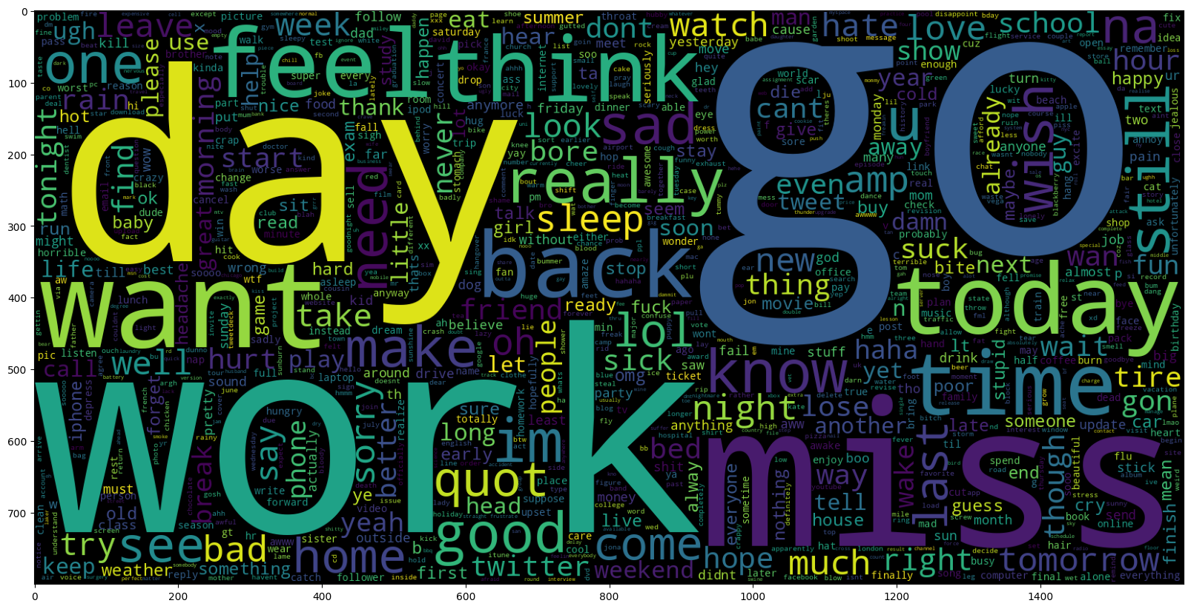

data_pos = X['text'][800000:]

wc = WordCloud(max_words = 1000 , width = 1600 , height = 800,

              collocations=False).generate(" ".join(data_pos))

plt.figure(figsize = (20,20))

plt.imshow(wc)

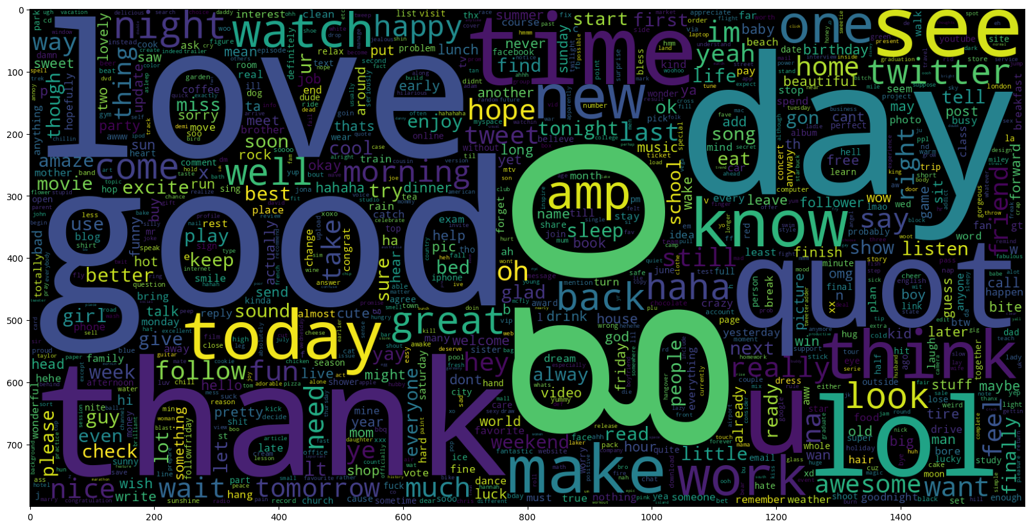

X_train, X_test, y_train, y_test = train_test_split(X, Y, test_size=0.2, random_state=42)

print("TRAIN size:", len(X_train))

print("TEST size:", len(X_train))



import gensim

# WORD2VEC

W2V_SIZE = 300

W2V_WINDOW = 7

W2V_EPOCH = 32

W2V_MIN_COUNT = 10

documents = [_text.split() for _text in X_train.text]

w2v_model = gensim.models.word2vec.Word2Vec(window=W2V_WINDOW,

                                            min_count=W2V_MIN_COUNT,

                                            workers=8)

w2v_model.build_vocab(documents)

words = w2v_model.wv.key_to_index.keys()

vocab_size = len(words)

print("Vocab size", vocab_size)



w2v_model.train(documents, total_examples=len(documents), epochs=W2V_EPOCH)



**Finding similar words**

s = input()

w2v_model.wv.most_similar(s)

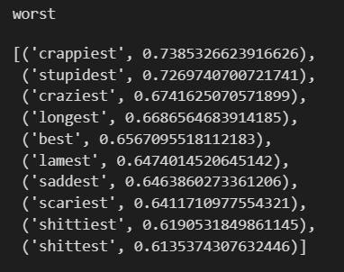

s = input()

w2v_model.wv.most_similar(s)

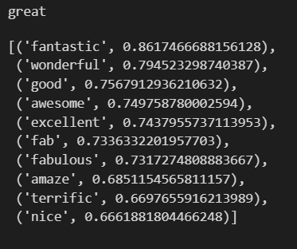

**Result**

Twitter Sentiment Analysis is done, wordclouds are generated, similar words are found.

**Github Links**

Name – Naman Anand

Reg.No. – RA2011029010013

Section – N2

Github Link:

<https://github.com/Naman-anand88/ML_Project_RA2011029010013>

Name – Srinivas T.B.

Reg.No. – RA2011029010015

Section – N2

Github Link:

<https://github.com/notahuman-1-0/ML_Project-RA2011029010015>

Name – Kirti Kalal

Reg.No. – RA2011029010031

Section – N2

Github Link:

<https://github.com/kirtikalal/MLProject_RA2011029010031>

**CONCLUSION AND FUTURE WORKS**

Twitter sentiment analysis has become a popular application of Natural Language Processing (NLP) techniques. It involves using algorithms and machine learning models to analyze the sentiment of tweets, which can be useful for various applications, such as brand monitoring, product analysis, and customer service.

Sentiment analysis on Twitter using word clouds and similar word analysis can provide valuable insights into public opinion and sentiment related to a particular topic or product. This type of analysis can help businesses and organizations understand their customers or the general public and identify potential areas for improvement or opportunities.

A word cloud is a visual representation of the most frequently occurring words in a dataset, with the size of each word indicating its frequency. The word cloud can help to identify the most common themes and topics discussed on Twitter related to the sentiment of interest. By analyzing the word cloud, we can gain an understanding of the most common themes and topics associated with the sentiment of interest.

Also, finding similar words helps to find which words are more used in place of a word to represent an emotion.

Overall, sentiment analysis on Twitter using word clouds and similar word analysis can provide valuable insights into public opinion and sentiment related to a particular topic or product. This type of analysis can help businesses and organizations understand their customers or the general public and identify potential areas for improvement or opportunities.

**Future Works**

The future of Twitter sentiment analysis is promising, as the use of social media platforms continues to grow and evolve. Here are some potential developments that may shape the future of Twitter sentiment analysis:

1. Advances in Natural Language Processing (NLP) techniques: As NLP techniques continue to improve, sentiment analysis algorithms may become more accurate and reliable. This could lead to better insights and decision-making for businesses, organizations, and governments.

2. Integration with other data sources: Twitter sentiment analysis may be integrated with other data sources, such as customer feedback surveys or sales data, to provide a more comprehensive understanding of customer sentiment and behavior.

3. Real-time sentiment analysis: Real-time sentiment analysis can provide immediate insights into customer sentiment, allowing businesses and organizations to respond quickly to feedback and concerns.

4. Use of machine learning: Machine learning algorithms can learn from past data to improve sentiment analysis accuracy and adapt to changing language usage and trends.

5. Analysis of visual content: Twitter sentiment analysis may expand to include analysis of visual content, such as images and videos, to provide a more complete understanding of customer sentiment.

6. Sentiment analysis of multiple languages: As Twitter continues to be used globally, sentiment analysis may expand to include multiple languages, allowing businesses and organizations to analyze sentiment across multiple markets.

Overall, the future of Twitter sentiment analysis is likely to be shaped by advances in technology, the growth of social media platforms, and the increasing need for businesses, organizations, and governments to understand public sentiment and behavior. As sentiment analysis techniques continue to evolve and improve, businesses and organizations will be better equipped to make informed decisions and improve their products, services, and policies based on customer feedback and sentiment.

**REFERENCES**

1. Sentiment analysis (<https://en.wikipedia.org/wiki/Sentiment_analysis>)

2. Pandas Documentation (<https://pandas.pydata.org/docs/>)

3. Seaborn Documentation (<https://seaborn.pydata.org/>)

4. Wordcloud Documentation (<https://pypi.org/project/wordcloud/>)

5. Matplotlib.pyplot Documentation

(<https://matplotlib.org/3.5.3/api/_as_gen/matplotlib.pyplot.html>)

6. NLTK Documentation (<https://www.nltk.org/>)

7. Scikit-learn Documentation (<https://scikit-learn.org/stable/>)

8. Re Documentation (<https://docs.python.org/3/library/re.html>)

9. Stopwords Documentation (<https://pypi.org/project/stop-words/>)

10. WordNetLemmatizer Documentation

(<https://www.nltk.org/_modules/nltk/stem/wordnet.html>)